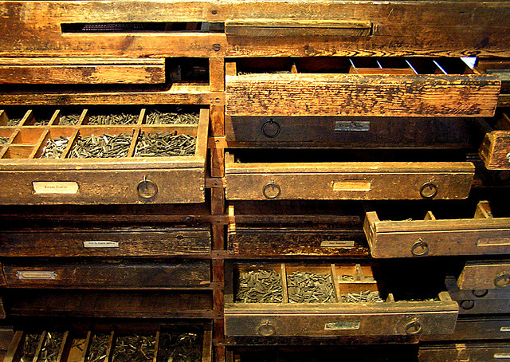Building Better Boxes

in a Culture of Innovation

The Anvil Centre, Room 411

The Digital Cultures Lab at Douglas College

Thursday, 17 September 2015 at 5:30 PM

New Westminster, BC

Registration Required

Ever wonder about 3D printing, fast prototyping, desktop fabrication, wearables, creative circuitry, and everything else associated with popular trends in technology? The inaugural Innovation Series workshop at the New Westminster Anvil Centre will provide a hands-on experience with some of these concepts and machines while connecting members of the New Westminster community with each other and the innovators who work here.

The workshop will feature 3D printing activities, the fabrication of circuitry, prototyping processes, and innovation strategies. Led by members of the Douglas College Digital Cultures Lab, the session will encourage participants to think differently about the mythologies of technology while at the same time facilitating hands-on opportunities with emerging technological objects and tools.

Register by searching google for “Eventbrite Digital Cultures Lab Boxes”

Or scan this QR Code:

 